ISD TERM PROJECT
<Software Requirements Specification>

Virtual Learning Platform



Project Advisor

Hira Tayyab

Presented by:
Group ID: 0056

Student Name: Bakhtawar Fatima

Faculty of Information Technology

University of Central Punjab

Software Requirements Specification

Version 1
Virtual Learning Platform

Advisor: Hira Tayyab

Group 0056

Member Name | Primary Responsibility | Roll No
Bakhtawar Fatima | Team Leader, Documentation, and UI Planning | 0056

Table of Contents
Table of Contents iii
List of Figures v
List of Tables vi
Revision History vii
1. Introduction and Background

1.1 Product (Problem Statement)
In today’s world, the demand for digital learning has increased rapidly due to global connectivity, flexible learning preferences, and the integration of technology in education. However, even with the availability of multiple e-learning tools such as Google Classroom, Moodle, and Microsoft Teams, both teachers and students still encounter several issues. Teachers often struggle to organize class materials, manage assignments, and assess performance efficiently, while students find it challenging to keep track of their learning resources, deadlines, and feedback within scattered systems.
The Virtual Learning Platform is designed to overcome these limitations by providing a unified environment that connects teachers and students within a single, interactive, and easy-to-use interface. It will allow teachers to create courses, upload materials, assign quizzes and assignments, and make announcements, while students will be able to view lessons, submit tasks, and monitor their academic progress. The platform’s primary goal is to simplify the learning process, enhance interaction, and make online education more structured and engaging.

1.2 Background
Education has evolved from traditional classrooms to virtual spaces. The recent shift to online learning during global crises like the COVID-19 pandemic accelerated the adoption of digital learning solutions. However, the transition exposed multiple weaknesses from the lack of student engagement to disorganized communication and the absence of integrated systems. Many educators still rely on multiple disconnected applications such as email, messaging apps, and file-sharing platforms to manage their teaching tasks. This fragmentation not only wastes time but also affects learning quality.
To address these gaps, the Virtual Learning Platform introduces an integrated solution where learning materials, assignments, quizzes, and announcements coexist harmoniously. It merges all educational functions into one system, making the teaching and learning process efficient, organized, and interactive. The platform can serve schools, universities, and online academies, ensuring inclusivity and simplicity for every user regardless of their technical skill level.

1.3 Scope
The scope of the Virtual Learning Platform encompasses the core functionalities of a complete online learning environment. It is intended to support both teaching and learning processes by offering distinct but interconnected interfaces for teachers and students. The system aims to reduce manual work, centralize learning materials, and facilitate performance tracking.
The main aspects covered under the project’s scope include:
For Teachers:
- Creation and management of courses.
- Uploading of study materials such as documents, presentations, or video links.
- Assignment creation with deadlines and instructions.
- Quiz creation for student assessment.
- Publishing announcements and communicating updates to students.
For Students:
- Access to uploaded learning materials.
- Viewing of active and completed assignments.
- Submission of tasks before deadlines.
- Attempting quizzes and viewing their scores.
- Reading announcements and tracking academic progress.
The system will act as a one-stop platform for all academic interactions between teachers and students.

1.4 Objective(s)/Aim(s)/Target(s)
The Virtual Learning Platform is designed with clear educational and technological objectives in mind. The project aims to enhance the quality of online education by providing a reliable, organized, and visually appealing system for academic management. Its main purpose is not only to support virtual learning but also to simplify how both educators and learners interact digitally.
The key objectives are as follows:
- To create a digital platform where teachers and students can interact seamlessly in a structured academic environment.
- To simplify the process of course creation, material sharing, and student assessment.
- To promote self-paced learning and accessibility for students anytime, anywhere.
- To design an intuitive interface that can be easily navigated by users without technical training.
- To track student performance and maintain transparency in grading and feedback.
- To provide a platform adaptable to various educational levels, including schools, colleges, and online academies.
These objectives collectively contribute to building a system that not only delivers knowledge but also improves communication, engagement, and efficiency.

1.5 Challenges
Developing a comprehensive Virtual Learning Platform involves several technical and design challenges. The first challenge lies in creating a user interface that accommodates two entirely different user groups teachers and students yet maintains simplicity and aesthetic appeal. The second challenge is ensuring that users can complete complex academic actions, such as uploading or submitting files, through minimal steps.
Moreover, ensuring smooth navigation between multiple modules such as courses, quizzes, assignments, and announcements without confusing users requires careful interface planning. Another challenge is managing large amounts of academic content in an organized and visually consistent format. Finally, achieving full responsiveness across devices and ensuring accessibility for users with varying levels of technical proficiency are key design concerns.
Some of the major challenges include:
- Designing separate dashboards with clear and role-based functions.
- Maintaining consistent user experience across different devices.
- Organizing course materials in a systematic yet user-friendly manner.
- Ensuring effective communication between students and teachers.
- Managing performance and submission data efficiently.
1.6 Learning Outcomes
The development of this project provides valuable learning opportunities from both technical and managerial perspectives. It enhances understanding of software engineering principles such as requirement gathering, modular system design, and user interface development. It also improves creative and analytical thinking through the process of designing a real-world education system.
- Through this project, one learns how to:
- Identify and document system requirements for educational software.
- Apply principles of user interface and user experience (UI/UX) design.
- Design structured workflows for digital learning environments.
- Collaborate effectively within a team while following documentation standards.
- Translate user needs into functional modules and clear design specifications.
By completing this project, learners gain the experience of planning, designing, and presenting a real-world software solution based on user requirements.

1.7 Nature of End Product
The final system will be a Virtual Learning Platform that provides complete academic management in digital form. It will consist of two main interfaces: one for teachers and another for students. Both interfaces will be visually distinct yet connected through common modules such as courses, assignments, and announcements.
The system will allow teachers to handle all academic tasks digitally, reducing paperwork and manual work. Students, on the other hand, will experience an interactive, visually engaging, and convenient learning environment. The platform will serve as a bridge between educators and learners, integrating all core learning activities into one digital space.
1.8 Completeness Criteria
The system will be considered complete when it successfully fulfills all major functional and design requirements. This includes ensuring that all screens are fully navigable, every role-based feature operates correctly, and the user experience is smooth and consistent.
The following criteria define project completeness:
- All modules, including Login, Dashboard, Courses, Assignments, Quizzes,Announcements, and Profile, are fully implemented.
- Both teacher and student roles function independently and correctly.
- The system supports smooth transitions between modules and logical navigation.2
- The design meets all accessibility and usability standards.
- The project passes validation through testing and review feedback.
1.9 Business Goals
The primary business goal of this project is to deliver an effective, low-cost, and easily deployable solution for online learning. Educational institutions constantly seek platforms that balance affordability, functionality, and simplicity. The Virtual Learning Platform has the potential to meet these needs, making it suitable for schools, academies, and private tutors.
From a business perspective, this system can be scaled and customized for specific clients or institutions. It can also serve as a base model for startups or educational software companies aiming to offer e-learning products in developing markets.

1.10 Related Work/ Literature Survey/ Literature Review
Existing e-learning systems such as Google Classroom, Blackboard, and Moodle have established themselves as industry standards. However, each of these platforms comes with drawbacks, including complex interfaces, heavy dependency on internet bandwidth, and limited customization for smaller institutions.
Research in educational technology shows that learners engage more effectively with platforms that are visually simple, interactive, and well-structured. Studies also suggest that excessive complexity in interfaces leads to reduced motivation and higher dropout rates.
The Virtual Learning Platform is inspired by the strengths of existing tools but aims to overcome their weaknesses by focusing on clarity, simplicity, and accessibility. It provides only essential yet powerful features, making it more approachable for both teachers and students

1.11 Document Conventions
All interface elements such as buttons and options are written in bold text (for example: Login, Submit, Dashboard). Each section follows a sequential numbering system for clarity. Tables and figures, where used, will be labeled for easy reference. The term user collectively refers to both teachers and students unless specified otherwise.

2. Overall Description
The Virtual Learning Platform is a modern educational system designed to provide a digital environment for teachers and students to interact, share learning materials, submit assignments, conduct quizzes, and monitor progress. It aims to create a structured and organized approach to online learning through an intuitive and easy-to-navigate interface. The platform ensures that both instructors and learners can perform their academic tasks efficiently using a centralized, interactive, and accessible application.

2.1 Product Features
The Virtual Learning Platform offers multiple features that streamline academic processes and enhance the teaching and learning experience. Each feature focuses on user-friendliness, clarity, and accessibility.
Key Features:
- User Authentication:
The system allows users to log in or sign up as either a teacher or a student, ensuring data privacy and personalized access.
- Role-Based Dashboard:
The application provides separate dashboards for teachers and students, each containing relevant options according to their roles.
- Teacher Dashboard: Create courses, upload material, post announcements, view assignments, and create quizzes.
- Student Dashboard: Access enrolled courses, view uploaded materials, submit assignments, attempt quizzes, and view progress reports.
- Course Management:
Teachers can create, name, and describe courses. Students can access courses they are enrolled in and view related content such as lecture notes, documents, or videos.
- Assignment Handling:
Teachers can upload assignments with due dates, while students can submit their solutions directly. Submitted work can be viewed and updated before the deadline.
- Quiz Module:
The system includes an interactive quiz section with multiple-choice questions. Students can view their results immediately after submission, and teachers can analyze class performance.
- Announcements and Notifications:
Teachers can post announcements or reminders visible to all enrolled students. Notifications are sent for new assignments, quizzes, or updates.
- Discussion Forum:
A space for students to interact with teachers and classmates, promoting collaboration, peer support, and communication.
- Progress Tracking:
Students can view their performance summaries, grades, and submission history, helping them monitor academic improvement.
- Profile Management:
Both users can edit their personal details such as name, password, or profile image through an easy-to-use profile page.
2.2 User Classes and Characteristics
The platform is designed for two main user classes, each with specific characteristics and system interactions.
1. Teachers
Characteristics:
- Experienced in using digital tools for educational purposes.
- Require functionalities to upload, manage, and evaluate learning materials.
- Need to communicate effectively with students through announcements or discussions.
- Desire organized access to students’ submissions and performance data.
Responsibilities:
- Create and manage courses.
- Upload assignments, notes, and quizzes.
- Review student submissions and monitor progress.
- Interact with students through feedback and announcements.

2. Students
Characteristics:
- Require an easy and interactive system for accessing course materials.
- Need to submit assignments, attempt quizzes, and receive grades promptly.
- Prefer simple navigation and clear instructions.
- Expect constant updates and feedback from instructors.
Responsibilities:
- Enroll in courses.
- View and download learning materials.
- Submit assignments within deadlines.
- Attempt quizzes and review performance reports.
2.3 Operating Environment
The Virtual Learning Platform is designed to operate on multiple environments and devices to ensure accessibility and flexibility. It will function smoothly across various hardware and software configurations.
Hardware Requirements:
- Mobile Device, Tablet, or Personal Computer.
- Minimum RAM: 2 GB.
- Storage: 200 MB available space.
- Stable Internet Connection for real-time updates.
Software Requirements:
- Operating System: Android, Windows, or Web Browser (Chrome, Edge, Firefox).
- Browser Compatibility: Should support HTML5 and responsive layouts.
- Additional Dependencies: None required from the user side.
The system is built to provide a seamless experience regardless of platform or device type, ensuring consistent functionality across all environments.

2.4 Design and Implementation Constraints
Despite the platform’s simplicity, several design and implementation constraints are considered to maintain structure, usability, and maintainability.
Constraints include:
- The interface design must remain consistent across all screens for easy navigation.
- The application must be compatible with mobile and desktop screens through responsive design.
- Data fields and forms should follow standard naming conventions to avoid ambiguity.
- Limited storage space requires optimized use of visual elements and resources.
- The color palette and fonts must ensure readability and a professional academic theme.
- Accessibility standards must be followed to support users with visual or motor disabilities.
These constraints ensure the product maintains a balance between usability and performance while adhering to modern design principles.

2.5 Assumptions and Dependencies
Certain assumptions and dependencies have been identified during the design of this system to ensure smooth functionality and realistic planning.
Assumptions:
- Users have basic knowledge of digital devices and the internet.
- A stable internet connection is available for accessing course materials and updates.
- All users possess valid credentials and are registered under an institution or course.
- Teachers are responsible for maintaining updated content and assignments.
- Students will regularly check the platform for announcements and submissions.
Dependencies:
- The functionality of the platform depends on consistent network access and device compatibility.
- Proper synchronization of uploaded materials and user interactions is required.
- Any third-party service (such as cloud storage for files) must remain active and reliable.
- Security measures such as data encryption and role-based access control rely on the underlying system architecture.

3. Project Management
3.1 Work Breakdown Structure (WBS)
For the Online Learning Platform Project, the WBS is structured as follows:
1. Project Initiation
- Requirement Gathering: Collect detailed functional and non-functional require
- Feasibility Study: Analyze technical, financial, and operational feasibility to ensure project viability.
2. System Design
- Database Design: Plan and create a structured database to store assignments, quizzes, scores, and user information.
- UI/UX Design: Design intuitive user interfaces and seamless user experiences for both students and teachers.
- Module Design: Design core modules such as Assignments, Quizzes, and Notifications to meet project requirements.
3. Implementation
- Frontend Development: Develop the user-facing interface using suitable technologies.
- Backend Development: Implement server-side logic, database connectivity, and core application functionality.
- Integration of Modules: Integrate all modules to ensure smooth communication and functionality across the platform.
4 Testing
- Unit Testing: Test individual modules to ensure each component functions correctly.
- System Testing: Verify that the complete system meets functional and performance requirements.
- User Acceptance Testing (UAT): Obtain stakeholder approval to confirm that the system fulfills intended use.
5. Deployment
- Server Setup: Configure servers and network settings for hosting the platform.
- Application Deployment: Launch the application for end-users.
6. Maintenance & Support
- Bug Fixing: Resolve issues reported during post-deployment use.
- Updates and Enhancements: Continuously improve the system by adding new features and enhancing performance.
This WBS ensures a structured approach to project management, clarifies responsibilities, and provides a roadmap to complete the project efficiently and within schedule.

3.2 Create Milestone table

Milestone ID | Task/Phase | Start Date | End Date | Responsible Party
M1 | Requirement Gathering | 01-Jan-25 | 02-Jan-25 | Project Manager
M2 | System Design | 03-Jan-25 | 04-Jan-25 | Design Team
M3 | Implementation | 05-Jan-25 | 07-Jan-25 | Development Team
M4 | Testing | 08-Jan-25 | 09-Jan-25 | QA Team
M5 | Deployment | 10-Jan-25 | 10-Jan-25 | DevOps Team
M6 | Maintenance & Support | 11-Jan-25 | Ongoing | Support Team

3.3 Develop an Activity Graph

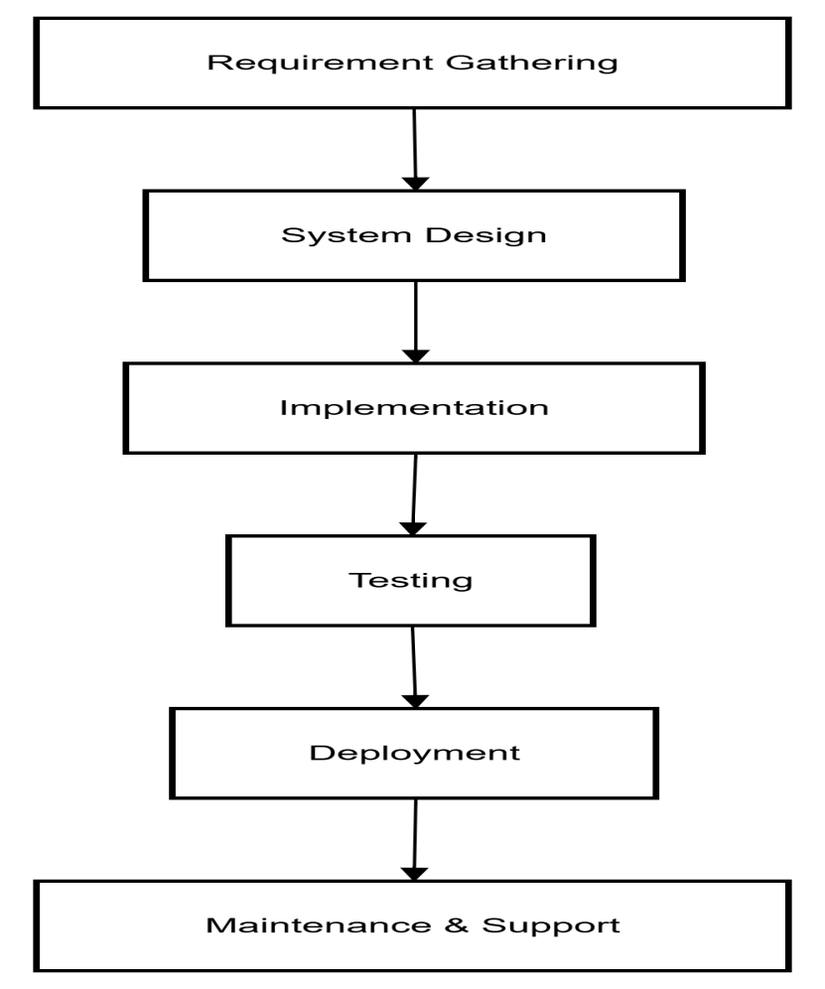

3.4 Find the Critical Path

For the Online Learning Platform Project, the main tasks, their durations, and dependencies are:
Task | Duration (Days) | Dependencies
Requirement Gathering | 2 | None
System Design | 2 | Requirement Gathering
Implementation | 3 | System Design
Testing | 2 | Implementation
Deployment | 1 | Testing
Maintenance & Support | Ongoing | Deployment
Step 1: Identify all paths through the project
Requirement Gathering → System Design → Implementation → Testing → Deployment → Maintenance & Support
Step 2: Calculate total duration of each path
2 + 2 + 3 + 2 + 1 = 10 days (excluding ongoing maintenance.
Step 3: Determine the Critical Path
The Critical Path is:
Requirement Gathering → System Design → Implementation → Testing → Deployment
Any delay in these tasks will delay the project completion.
Step 4: Slack Analysis
Tasks not on the critical path (if any) have slack, meaning they can be delayed without affecting the overall project timeline.
In this project, all core tasks are on the critical path due to sequential dependencies.

3.5 Create a Gantt chart
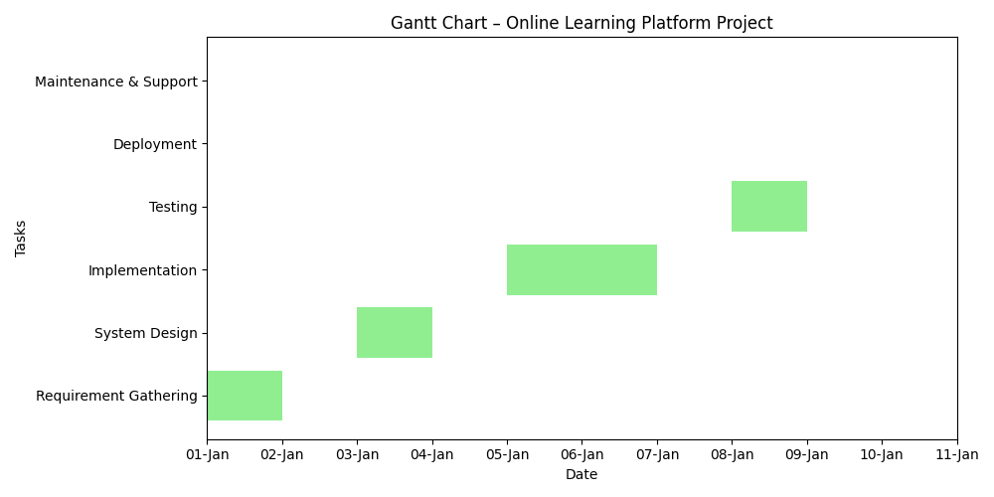

~~~~~~~~~~ Phase II ~~~~~~~~~~ 4

4. Functional Requirements
Functional requirements describe what the system must do and how users interact with it. The Virtual Learning Platform includes multiple functions for both teachers and students to make online learning smooth, structured, and accessible. Each functionality is represented as a use case.
Actors:
- Teacher
- Student
Use Cases:
- Login / Logout
- Manage Courses
- Upload / Access Materials
- Post / View Announcements
- Create / Attempt Quiz
- Submit / Review Assignments
- View Progress
4.1 Use Case 1: Login
Field | Description
Identifier | UC-1
Purpose | To allow teachers and students to securely log in to their respective dashboards.
Priority | High
Pre-conditions | User must be registered with valid credentials.
Post-conditions | User is redirected to their respective dashboard (Teacher or Student).
Typical Course of Action
S# | Actor Action | System Response
1 | User enters username and password | System verifies credentials
2 | Credentials are valid | User is redirected to dashboard
3 | Credentials are invalid | System displays an error message

4.2 Use Case 2: Course Management

Field | Description
Identifier | UC-2
Purpose | To allow teachers to create and manage courses while enabling students to view and join them.
Priority | High
Pre-conditions | User must be logged in.
Post-conditions | Course information is saved and visible to students.
Typical Course of Action

S# | Actor Action | System Response
1 | Teacher selects “Create Course” | System opens a new course creation form
2 | Teacher enters course name and description | System validates and saves data
3 | Student joins course | System adds student to course list

4.3 Use Case 3: Assignment Submission
Identifier: UC-3
Purpose: To allow students to submit assignments and teachers to view them.
Priority: High
Pre-conditions: Student must be enrolled in a course with active assignments.
Post-conditions: Assignment is submitted and stored for grading.
Typical Course of Action
S# | Actor Action | System Response
1 | Teacher uploads assignment with deadline | System posts assignment on course page
2 | Student uploads solution | System stores submission and timestamp
3 | Teacher reviews work | System marks as “graded” or “pending”

4.4 Use Case 4: Quiz Management
Identifier: UC-4
Purpose: To let teachers create quizzes and students attempt them.
Priority: Medium
Pre-conditions: User must be logged in and enrolled in the course.
Post-conditions: Scores are saved and displayed.
Typical Course of Action
S# | Actor Action | System Response
1 | Teacher creates quiz questions | Quiz added to course list
2 | Student attempts quiz | System displays questions sequentially
3 | Student submits quiz | System auto-calculates score

4.5 Use Case 5: Announcements
Identifier: UC-5
Purpose: To allow teachers to post updates and students to view them.
Priority: Medium
Pre-conditions: Teacher must be logged in.
Post-conditions: Announcement visible to all enrolled students.
Typical Course of Action
S# | Actor Action | System Response
1 | Teacher writes announcement | System saves announcement
2 | Students open “Announcements” | System displays latest updates

Requirements Analysis and Modeling

1.Requirement Analysis
For the Virtual Learning Platform, requirement analysis was conducted through observation, brainstorming sessions, and detailed study of existing learning management systems such as Google Classroom, Moodle, and Edmodo. The purpose was to identify the most useful features while maintaining simplicity, accessibility, and efficiency.
The analysis revealed two main user categories teachers and students each having distinct roles and responsibilities. Based on these, both functional and non-functional requirements were defined.

A. Functional Requirements
Functional requirements describe what the system will do the specific features and operations it must perform to fulfill its objectives.
For Teachers:
- The teacher must be able to log in using secure credentials.
- The teacher can create, edit, or delete courses.
- The teacher can upload learning materials (documents, videos, or notes).
- The teacher can create and assign quizzes and assignments.
- The teacher can post announcements visible to all students.
- The teacher can review submissions and assign grades.
- The teacher can monitor student progress and provide feedback.
For Students:
- The student must be able to register and log in securely.
- The student can view and join courses.
- The student can access uploaded materials and announcements.
- The student can submit assignments before deadlines.
- The student can attempt quizzes and view results.
- The student can track performance and progress reports.
Each of these functional requirements was verified to ensure that it supports the core aim of improving online teaching and learning efficiency.

B. Non-Functional Requirements
Non-functional requirements define how the system performs its functions rather than what it does. These ensure the system’s overall quality, performance, and reliability.
Key Non-Functional Requirements:
- Usability:
The interface must be clean, interactive, and easy to use for both teachers and students, even with limited technical knowledge.
- Performance:
The system should respond quickly to user actions and allow smooth transitions between screens. Pages should load within two to three seconds under normal conditions.
- Security:
Each user must have unique login credentials, and passwords must be securely stored. Unauthorized access to teacher or student data should be strictly prevented.
- Reliability:
The platform must function consistently without errors and ensure data integrity during all operations.
- Scalability:
The system should support future expansion, allowing more users, courses, and features without structural changes.
- Portability:
The platform should run efficiently on both desktop and mobile devices across various browsers and operating systems.
By thoroughly analyzing these requirements, the foundation was set for modeling and designing a structured, efficient, and user-centered learning system.

2.Modeling
Once the requirements were fully analyzed and documented, the next step was modeling the process of representing those requirements visually and logically. Modeling helps in understanding how the system components will work together and how users will interact with the system. It serves as a blueprint for developers and designers to visualize workflows, data movement, and relationships between entities.
For the Virtual Learning Platform, the modeling process included Use Case Modeling, Data Flow Modeling, Activity Modeling, and Entity Relationship Modeling (ERD).

A. Use Case Modeling
The Use Case Model represents all possible interactions between users (actors) and the system. It defines each functionality from the user’s perspective.
Actors:
- Teacher
- Student
Main Use Cases:
- Login / Logout
- Manage Courses
- Upload / View Materials
- Create / Attempt Quizzes
- Submit / Review Assignments
- Post / Read Announcements
- View Progress
Explanation:
Teachers create and manage all learning activities, while students access and participate in them. Both users log in through a common interface, and their dashboards display role-specific features.

B. Data Flow Modeling (DFD)
The Data Flow Diagram shows how data moves through the system, identifying the main processes, data stores, and external entities.
Represents the entire system as a single process interacting with two main entities:
- Teacher (inputs materials, quizzes, assignments)
- Student (receives materials, submits work, attempts quizzes)
The system is divided into sub-processes such as Login, Course Management, Assignment Handling, and Quiz Processing. Each process interacts with relevant data stores (User Data, Course Data, Assignment Data, Quiz Data).

C. Activity Modeling
The Activity Diagram illustrates the sequence of operations for each user. It shows how users perform tasks and how the system responds to their actions.
Teacher Activity Sequence:
- Login to system
- Create or manage course
- Upload materials or assignments
- Post announcements
- Review submissions and results
- Logout
Student Activity Sequence:
- Login
- Access enrolled courses
- View materials and announcements
- Submit assignments or attempt quizzes
- Check progress
- Logout

D. Entity Relationship Modeling (ERD)
The ERD defines the relationships among different entities in the database. Each entity represents a table that stores data.
Entities:
- Teacher (Teacher_ID, Name, Email, Password)
- Student (Student_ID, Name, Email, Password)
- Course (Course_ID, Course_Name, Description, Teacher_ID)
- Assignment (Assignment_ID, Title, Due_Date, Course_ID)
- Quiz (Quiz_ID, Total_Questions, Course_ID, Marks)
- Submission (Submission_ID, Assignment_ID, Student_ID, Date_Submitted)
Relationships:
- One Teacher → Many Courses
- One Course → Many Assignments and Quizzes
- One Student → Many Submissions
- One Student → Enrolled in Many Courses

5. Nonfunctional Requirements
The Virtual Learning Platform is an educational management system designed to connect teachers and students in a digital classroom environment. While functional requirements define what the system does, the non-functional requirements define how effectively, efficiently, and securely the system performs those operations.
These requirements ensure that the platform remains reliable, fast, and easy to use, even when accessed by many users at once. The main non-functional requirements for this project are classified under performance, safety, security, and software quality attributes.

5.1 Performance Requirements
Performance is one of the most important factors for any learning management system. The Virtual Learning Platform must deliver a smooth and responsive user experience for both teachers and students, especially when multiple users are active simultaneously.

Performance Expectations:
- The system must ensure that every screen (such as the Login Page, Dashboard, Courses, Assignments, or Quizzes) loads within 3 seconds on a standard internet connection.
- The interface should remain fully responsive and functional across all supported devices (mobile phones, tablets, and computers).
- The platform should handle up to 50–100 active users at a time without freezing, lagging, or crashing.
- Uploading course materials or assignments (PDF files, documents, or images) should complete within 5 seconds.
- All transitions between pages (Dashboard → Courses → Assignments) should occur instantly without reload delays.
- The design should remain lightweight so that it can function smoothly even on low-end devices with limited RAM or storage.

Expected Performance Outcome:
The platform must support teachers in uploading and managing content without interruptions while allowing students to access materials, submit work, and attempt quizzes smoothly. Consistent speed and responsiveness will enhance user satisfaction and productivity.

5.2 Safety Requirements
Since the Virtual Learning Platform stores important educational data such as assignments, quiz results, and course materials, maintaining safety is essential to prevent accidental data loss or system failure.

Safety Measures
- All uploaded files must be safely stored in the system’s database.
- Before performing any sensitive operation (deleting a course, file, or assignment), the system should show a confirmation message.
- If a user loses connection during upload or submission, the system must pause/resume instead of losing progress.
- Automatic session timeout after 10 minutes of inactivity will prevent unauthorized access.
- Regular data backups must be maintained for recovery in case of data corruption or a system crash.
- Errors should display clear, friendly messages like: “Your session has expired, please log in again."
- Partially uploaded or incomplete data must never overwrite existing content until fully verified.
These safety requirements ensure all materials and submissions remain safe, retrievable, and protected from accidental operations.

5.3 Security Requirements
Security is crucial because the platform contains sensitive academic information such as user credentials, grades, and submissions.

Security Provisions:
- Each user logs in with unique credentials (email + password).
- Passwords stored in encrypted form for protection.
- Role-based access control (RBAC):
- Teachers create/modify courses.
- Students can only access and submit work for enrolled courses.
- After 3 failed login attempts, the account will be temporarily locked.
- Session-based authentication ends the session when the user logs out or closes the browser.
- Only the course creator (teacher) can modify or grade the course content
- Communication uses secure protocols (HTTPS) to avoid data interception.
- Input validation prevents SQL injection, XSS, and other malicious attacks.

These measures ensure all information from login details to grades stays protected from unauthorized access.

5.4 Additional Software Quality Attributes
Beyond core requirements, the platform must fulfill several quality standards for long-term usability and reliability.

1. Usability
The interface must be simple, clean, and easy to use for all age groups. Clear icons, consistent colors, and proper labels ensure smooth navigation.

2. Reliability
The system should operate without unexpected crashes, even under heavy usage, and must accurately maintain all stored information.

3. Maintainability
The design should be modular so that new features (like video lectures, live chat, analytics) can be added easily.

4. Portability
The system must run smoothly on Windows, Android, iOS, and major browsers (Chrome, Firefox, Edge).

5. Availability
The platform should remain online at all times during academic hours. Maintenance should occur during off-peak times.

6. Scalability
The architecture should support future growth more users, courses, and institutions without performance loss.

7. Accessibility
Readable fonts, proper contrast, and accessible UI ensure comfortable use even on low-end devices or by users with limited technical skills.

6. Other Requirements

1 Database Requirements
- The system must use a relational database to store user, course, assignment, quiz, and submission data.
- Each table must have a unique primary key.
- Referential integrity must be maintained using foreign keys.
- Backup of the database should be taken periodically to prevent data loss.

2 External Interface Requirements
- The system must support standard web browsers such as Google Chrome, Microsoft Edge, and Mozilla Firefox.
- The platform should be accessible via desktop, tablet, and mobile devices.
- File upload interfaces must support common formats such as PDF, DOCX, JPG, and PNG.

3 Legal and Ethical Requirements
- User data privacy must be ensured according to standard data protection policies.
- No user data should be shared with third parties without consent.
- Copyrighted learning material must only be uploaded by authorized users (teachers).

4 Reusability Requirements
- The system modules should be reusable for future educational platforms.
- Code structure should allow easy integration of new features such as live lectures or analytics.

7. Designing
7.1 Complete class diagram
The class diagram represents the static structure of the Virtual Learning Platform. It consists of a superclass User and two subclasses Teacher and Student, demonstrating inheritance. Core academic entities such as Course, Assignment, Quiz, Submission, and Announcement define the learning workflow. Associations and multiplicities show relationships between teachers, students, and courses. This diagram ensures modularity, reusability, and clarity in system design.

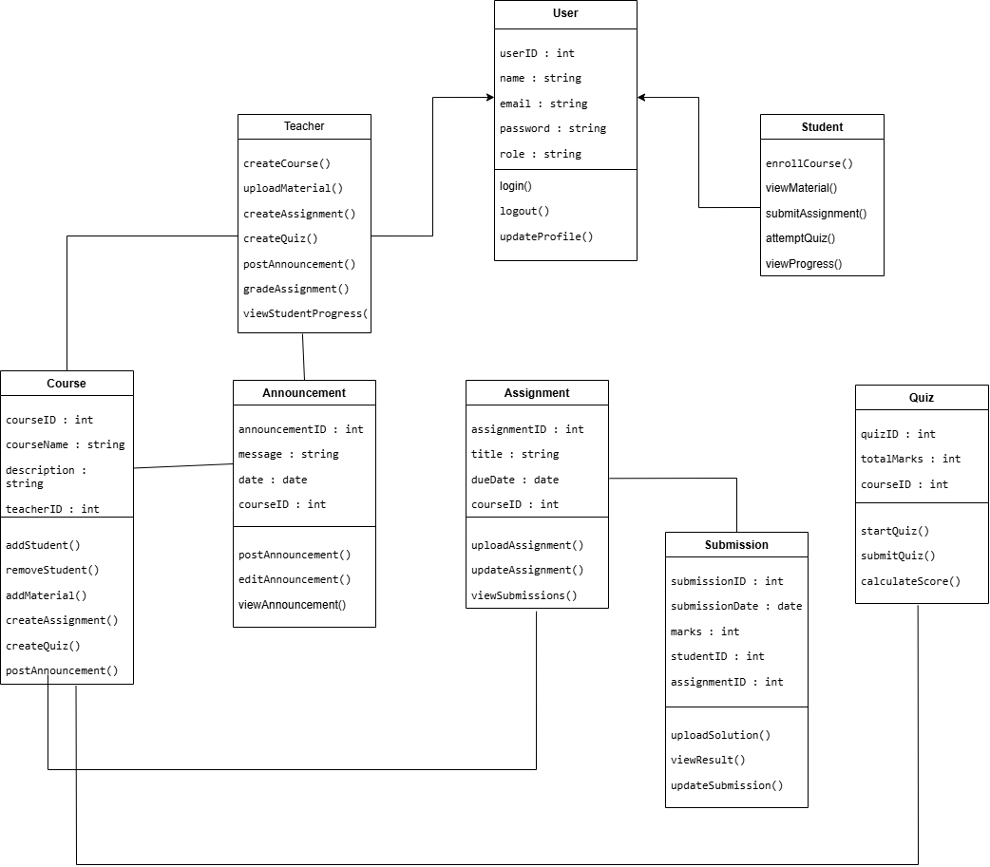

7.2 Complete Data Flow Diagram (DFD)
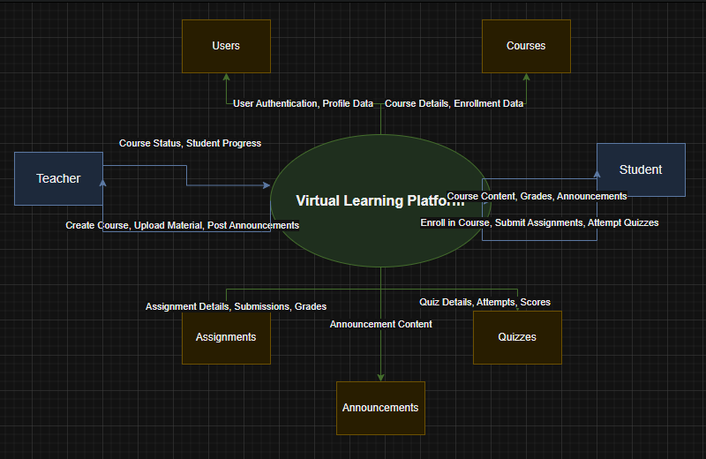
7.3 Complete ER Diagram
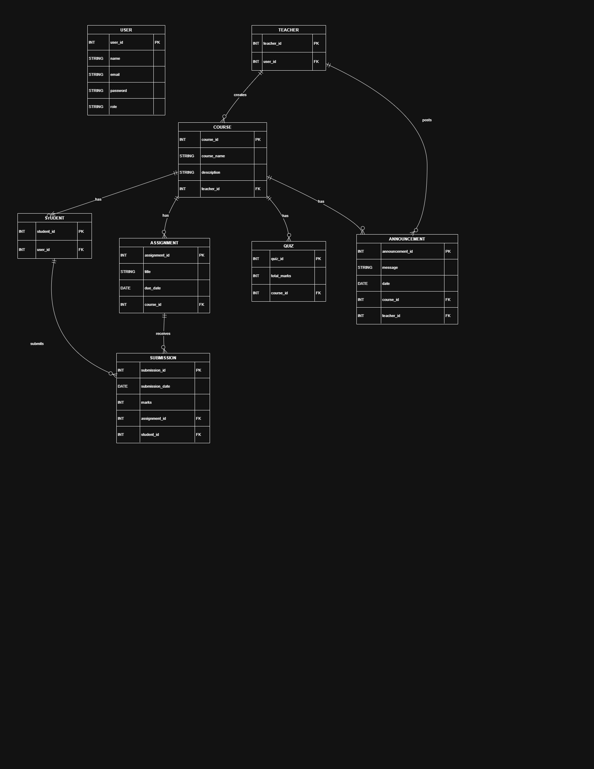
In ERD:
- User is a generalization / super-entity
- Teacher and Student are specializations
So User does NOT directly connect to Course, Assignment, etc.
Those relationships belong to Teacher and Student.

7.4 Physical design of your database

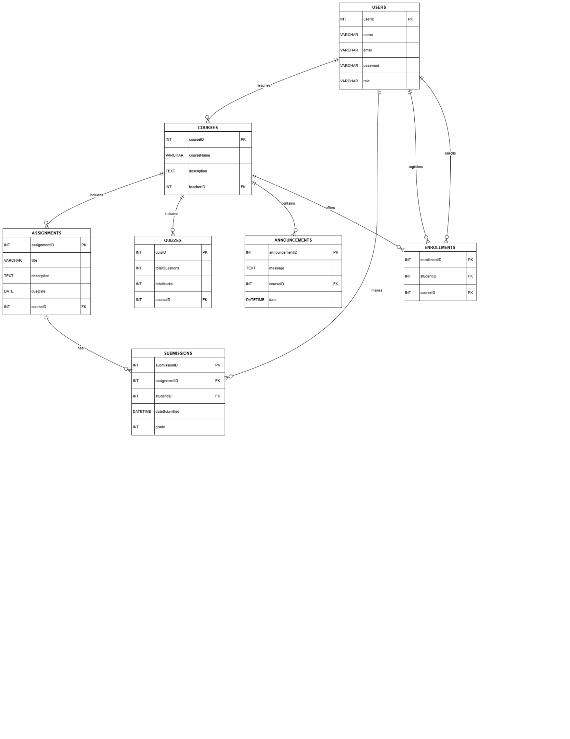

7.5 Information on use of design patterns while designing the modules
In designing the Learning Management System (LMS), several software design patterns are employed to ensure efficiency, maintainability, and scalability. The following design patterns are applied:
1. Singleton Pattern
The Singleton pattern is utilized to manage the database connection, ensuring that only a single instance of the connection exists throughout the application. This approach prevents multiple, unnecessary database connections, optimizes resource usage, and maintains consistency across the system.
2. Factory Pattern
The Factory pattern is applied for the creation of user objects based on their roles (e.g., Teacher or Student). This pattern encapsulates the object creation logic, allowing the system to generate different user types dynamically without exposing the underlying instantiation process. It also facilitates future extension to accommodate additional user roles with minimal code changes.
3. Observer Pattern
The Observer pattern is employed to handle announcements and notifications. When a teacher posts an announcement, all subscribed students are automatically notified. This design ensures real-time updates, reduces the need for manual checks, and maintains an efficient publish-subscribe mechanism within the LMS.
4. MVC (Model-View-Controller) Pattern
The LMS architecture follows the MVC pattern, which separates the application into three interconnected components:
Model: Handles data management and business logic, including courses, assignments, quizzes, and submissions.
View: Provides the user interface, displaying information such as course lists, dashboards, and notifications.
Controller: Manages user interactions, updates the model, and refreshes the view accordingly.
The adoption of these design patterns enhances modularity, maintainability, and scalability, ensuring a robust and efficient LMS.

7.6 Make a Sequence and a Collaboration diagram of following

7.6.1 Scenario 1
Assignment Submission:
Sequence Diagram:
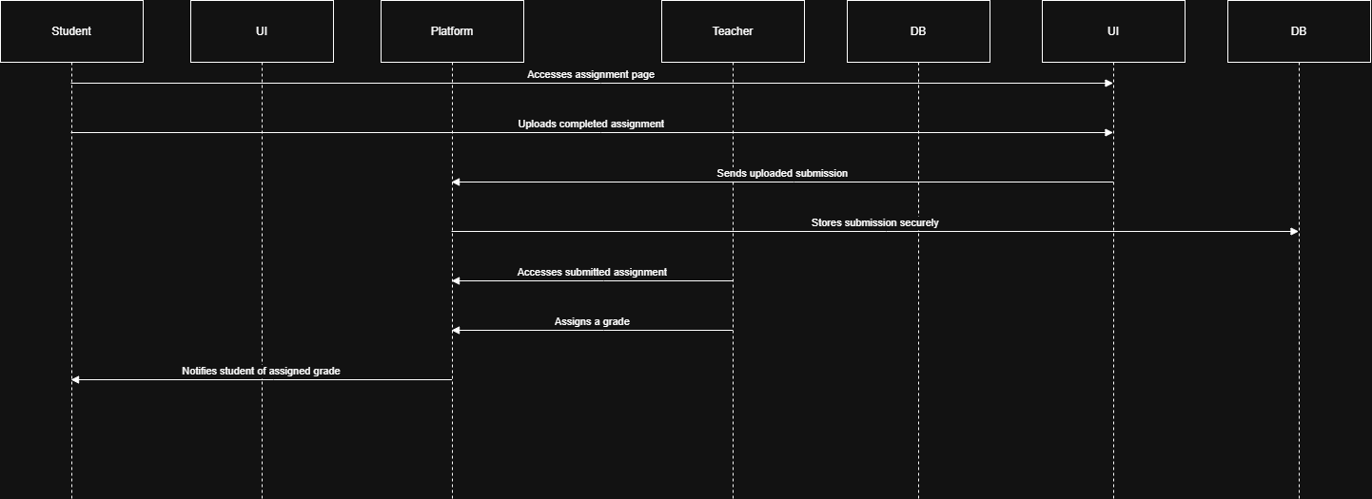
Collaboration Diagram:
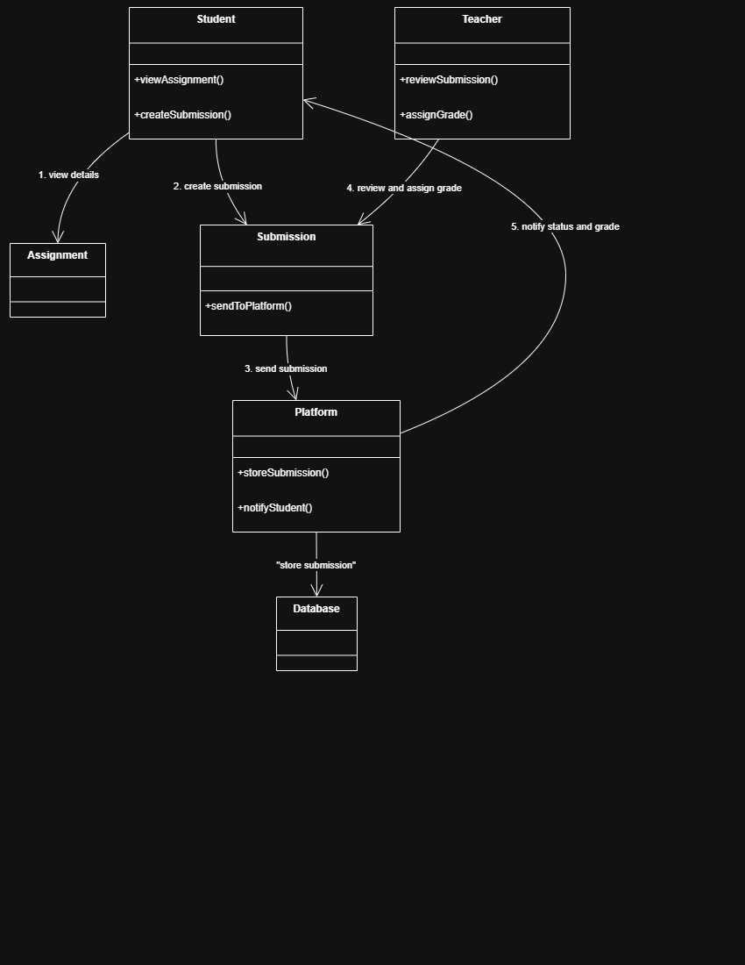
7.6.2 Scenario 2
Sequence:
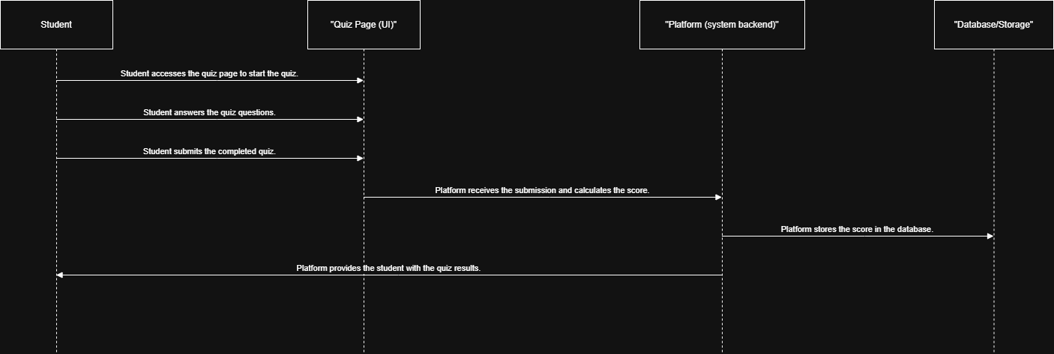
Collaboration:
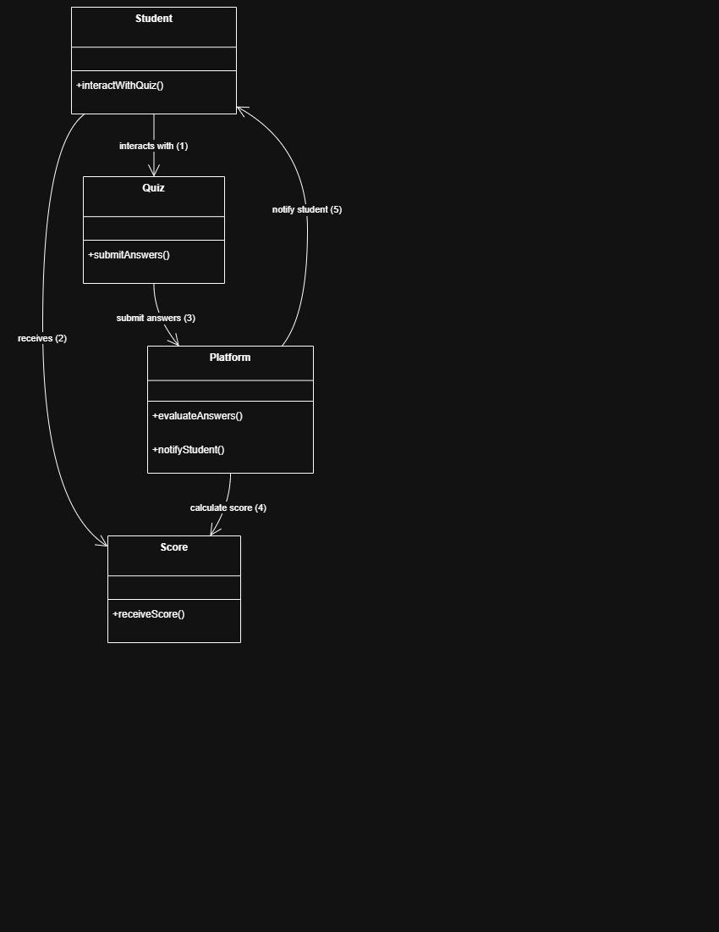
8. Estimation
8.1 Cost Benefit Estimation
Cost–Benefit Estimation for the Virtual Learning Platform evaluates the total development cost against the expected benefits in order to determine financial feasibility.
Estimated Costs for the Platform
Cost Component | Estimated Cost (PKR)
Development tools & software | 40,000
Design & documentation effort | 50,000
Development labor (team effort) | 80,000
Testing & review | 30,000
Total Estimated Cost | 200,000 PKR
Expected Benefits (1st Year)
Benefit Source | Estimated Value (PKR)
Institutional usage/license | 180,000
Reduced paperwork & manual work | 70,000
Maintenance & operational savings | 50,000
Total Estimated Benefit | 300,000 PKR

8.1.1 Return of Investment (ROI) {1st year}
ROI measures the financial return for every unit of cost invested.
ROI=Benefits/cost​= 300,000/200,000 = 1.5 ROI
Interpretation: For every 1 PKR invested in the Virtual Learning Platform, 1.5 PKR is expected as return in the first year, indicating a financially viable project.

8.1.2 %gain on ROI {1st year}
The percentage gain indicates the profit earned relative to the investment.
Formula: % Gain = (Benefits - Cost) / Cost x 100
Calculation: % Gain = (300,000 - 200,000) / 200,000 x 100 = 50%
Interpretation: A 50% gain demonstrates strong financial advantages, making the platform a profitable investment.

8.1.3 Payback Period in years
The Payback Period estimates how long it will take to recover the initial investment.
Formula: Payback Period (years) = Cost / Annual Benefit
Calculation: Payback Period = 200,000 / 300,000 ≈ 0.66 years
Interpretation: The development cost of the platform will be recovered in approximately 0.66 years (around 8 months), which is efficient and practical for an academic software project.

8.2 FP based Estimation
Function Point estimation measures the functional size of the platform based on its components. The identified components are:
Component Type | Count | Example in Platform
External Inputs (EI) | 10 | Assignment submissions, login forms
External Outputs (EO) | 8 | Grade reports, notifications
External Inquiries (EQ) | 6 | Course search, announcement checks
Internal Logical Files (ILF) | 7 | Student records, course data
External Interface Files (EIF) | 4 | Authentication API, external library
Weighted Function Points
Component | Weight | Total
EI | 4 | 40
EO | 5 | 40
EQ | 4 | 24
ILF | 10 | 70
EIF | 7 | 28
Total FP | -- | 202 FP
After applying complexity adjustment factors, the final Function Point count is approximately 180 FP, representing the platform’s functional size for development effort estimation.

8.3 COCOMO Estimation
The COCOMO model estimates the effort and development time based on the platform’s size and complexity.
Assumptions for the Virtual Learning Platform:
1 FP ≈ 50 Lines of Code (LOC)
Total LOC = 180 × 50 = 9,000 LOC
KLOC = 9
Effort Estimation (Organic Mode)
Effort (person-months) = 2.4 x (KLOC)^1.05 Effort = 2.4 x 9^1.05 9^1.05 ≈ 10.1 Effort ≈ 2.4 x 10.1 = 24.24 person-months
Development Time Estimation
Time (months) = 2.5 x (Effort)^0.38 Time = 2.5 x 24.24^0.38 24.24^0.38 ≈ 3.4 Time ≈ 2.5 x 3.4 = 8.5 months
Team Size Required
Team Size = Effort / Time = 24.24 / 8.5 ≈ 3 members
Interpretation: The platform can be developed within 8–9 months by a team of 3–4 members, confirming feasibility and alignment with the academic project timeline.

Conclusion:
All estimation techniques confirm that the Virtual Learning Platform is financially viable, functionally manageable, and can be developed efficiently within the academic period using a small team. The project is therefore feasible and justified.

9. References
• Google Classroom. https://classroom.google.com/. Accessed January 1, 2026.
• Moodle LMS. https://moodle.org/. Accessed January 1, 2026.
• Microsoft Teams for Education. https://www.microsoft.com/en/microsoft-teams/group-chat-software. Accessed January 1, 2026.
•
Appendix A: Glossary 11

List of Figures

List of Tables

Revision History
Name | Date | Reason For Changes | Version

Introduction and Background
You are required to write a brief introduction of your project and provide background. In this section you should provide the context and initial knowledge of the domain. You should also highlight the significance of problem and provide motivation behind the work being done.

Product (Problem Statement)
<Provide a short description of the software being specified.>

Background
<Describe the domain.>

Scope
< Describe the scope of the product that is covered by this SRS.>

Objective(s)/Aim(s)/Target(s)
<List all the objectives to be achieved after the completion of this project.>

Challenges

Learning Outcomes

Nature of End Product

Completeness Criteria
<State the criteria that if fulfilled will let evaluators consider the project as complete >

Business Goals
<List all the business/corporate goals addressed by this software.>

Related Work/ Literature Survey/ Literature Review

Document Conventions
<Describe any standards or typographical conventions that were followed when writing this SRS, such as fonts or highlighting that have special significance. For example, state whether italicized nouns represent external systems.>

Overall Description

Product Features
<Summarize the major features the product contains or the significant functions that it performs or lets the user perform. Details will be provided in Section 3, so only a high level summary is needed here. Organize the functions to make them understandable to any reader of the SRS.>

User Classes and Characteristics
<Identify the various user classes that you anticipate will use this product. User classes may be differentiated based on frequency of use, subset of product functions used, technical expertise, security or privilege levels, educational level, or experience. Describe the pertinent characteristics of each user class. Certain requirements may pertain only to certain user classes. Distinguish the favored user classes from those who are less important to satisfy.>

Operating Environment
<Describe the environment in which the software will operate, including the hardware platform, operating system and versions, and any other software components or applications with which it must peacefully coexist.>

Design and Implementation Constraints
<Describe any items or issues that will limit the options available to the developers. These might include: corporate or regulatory policies; hardware limitations (timing requirements, memory requirements); interfaces to other applications; specific technologies, tools, and databases to be used; parallel operations; language requirements; communications protocols; security considerations; design conventions or programming standards (for example, if the customer’s organization will be responsible for maintaining the delivered software).>

Assumptions and Dependencies
<List any assumed factors (as opposed to known facts) that could affect the requirements stated in the SRS. These could include third-party or commercial components that you plan to use, issues around the development or operating environment, or constraints. The project could be affected if these assumptions are incorrect, are not shared, or change. Also identify any dependencies the project has on external factors, such as software components that you intend to reuse from another project, unless they are already documented elsewhere (for example, in the vision and scope document or the project plan).>

Project Management.

Work Breakdown Structure (WBS).
<Create a WBS (approximate) for your project.>

Create Milestone table
< Create a table showing activities and their completion times (milestones) >

Develop an Activity Graph.
< Using this WBS develop an Activity Graph. Convert the graph such that it is helpful in estimating project completion.>

Find the Critical Path.
< Construct CPM using Forward backward pass method.>

Create a Gantt chart.
< Create a Gantt chart showing the progress of your project an indicating the current status of your project.>

~~~~~~~~~~ Phase II ~~~~~~~~~~

Functional Requirements
<All functional requirements are expressed as use-cases. Fill out the following template for each use-case. Don’t really say “Use-Case 1.” State the use-case name in just a few words e.g. “Withdraw Cash from ATM”. A use-case may have multiple alternate courses of action.>

<Provide a Use Case Diagram before describing the use cases.>

Name of Use-Case 1
Identifier |  | UC-1
Purpose |  | …
Priority |  | <Choose one from {High, Medium, Low}>
Pre-conditions |  | …
Post-conditions |  | …
Typical Course of Action
S# | Actor Action |  | System Response
1
2
3
…
Alternate Course of Action
S# | Actor Action |  | System Response
1
2
3
…
Table 1: UC-1

Name of Use-Case 2 (and so on)
*if you are able to discover 15+ use cases describe at least 3 of them minimum

Requirements Analysis and Modeling
<Include the following analysis models: use-case diagram, state diagram, decision table, event table etc.>

Nonfunctional Requirements*
*make sure all your requirements functional or non functional are testable

Performance Requirements
<If there are performance requirements for the product under various circumstances, state them here and explain their rationale, to help the developers understand the intent and make suitable design choices. Specify the timing relationships for real time systems. Make such requirements as specific as possible. You may need to state performance requirements for individual functional requirements or features.>

Safety Requirements
<Specify those requirements that are concerned with possible loss, damage, or harm that could result from the use of the product. Define any safeguards or actions that must be taken, as well as actions that must be prevented. Refer to any external policies or regulations that state safety issues that affect the product’s design or use. Define any safety certifications that must be satisfied.>

Security Requirements
<Specify any requirements regarding security or privacy issues surrounding use of the product or protection of the data used or created by the product. Define any user identity authentication requirements. Refer to any external policies or regulations containing security issues that affect the product. Define any security or privacy certifications that must be satisfied.>

Additional Software Quality Attributes
<Specify any additional quality characteristics for the product that will be important to either the customers or the developers. Some to consider are: adaptability, availability, correctness, flexibility, interoperability, maintainability, portability, reliability, reusability, robustness, testability, and usability. Write these to be specific, quantitative, and verifiable when possible. At the least, clarify the relative preferences for various attributes, such as ease of use over ease of learning.>

Other Requirements
<Define any other requirements not covered elsewhere in the SRS. These might include database requirements, external (hardware, software, or communication) interface requirements, internationalization requirements, legal requirements, and reuse objectives for the project.>

Designing

Complete class diagram
<including class attributes, methods and multiplicity is required>

Complete Data Flow Diagram (DFD)
< Context level DFD and level 1 DFD are required >

Complete ER Diagram
< Complete ERD is required >

Physical design of your database
<i.e. table names with attributes and their types>

Information on use of design patterns while designing the modules
<e.g. while making class diagram. Highlight/Mention the relevant classes>

Make a Sequence and a Collaboration diagram of following.

Scenario 1

Scenario 2

Estimation

Cost Benefit Estimation

Return of Investment (ROI) {1st year}
<Approximate estimations should be done after approximate estimation of values.
Formula of ROI = Benefits / Cost >

%gain on ROI {1st year}
< Values should be based on estimates of 8.1.1.
Formula of %gain on ROI = { (Benefits - Cost) / Cost } x 100>

Payback Period in years
<Values should be based on estimates of 8.1.1.
Formula of payback period = Cost / Benefit >

FP based Estimation
<Approximate estimation should be done using FP >

COCOMO Estimation
<Approximate estimation should be done using FP based COCOMO >

References
<List all books, conference papers, journal articles, websites, etc. used in preparing the content of this SRS. Provide enough information so that the reader could access a copy of each reference, including title, author, volume/edition number, page number(s), and publication year. Mention complete URLs for websites.>
< Must use Zotero reference Manager to maintain references in every phase in this section.>

Appendix A: Glossary
<Define all the terms necessary to properly interpret the SRS, including acronyms and abbreviations. You may wish to build a separate glossary that spans multiple projects or the entire organization, and just include terms specific to a single project in each SRS.>

